**DAY 3 CLASS EXERCISE LAB**

**TASK 01:** Create and Replay

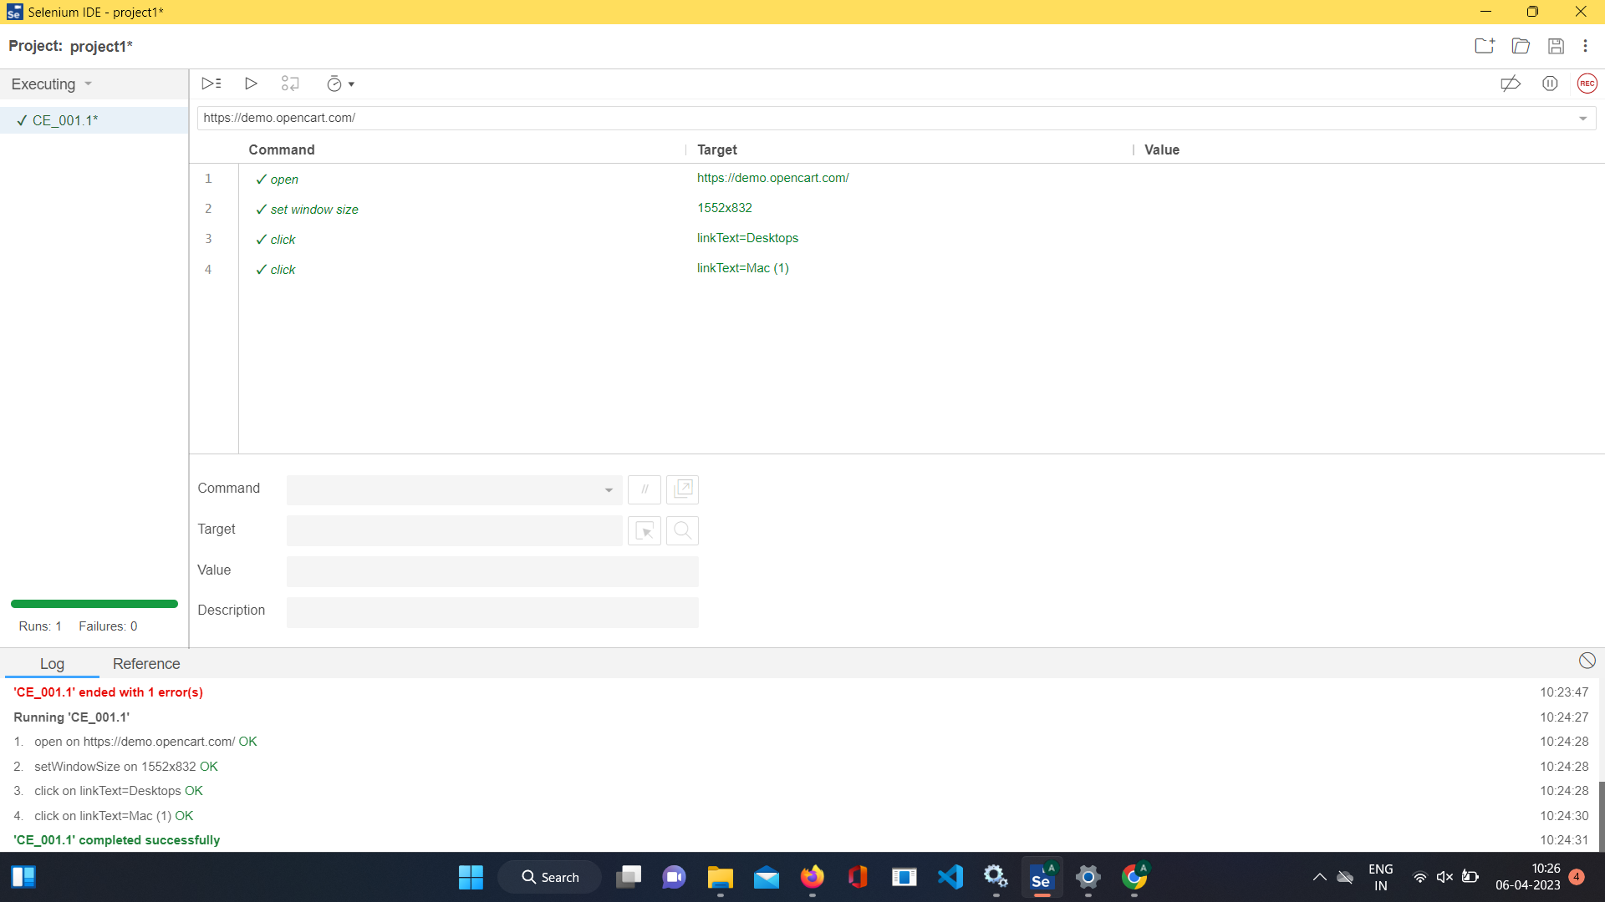

**Task 02:** Selenese Commands

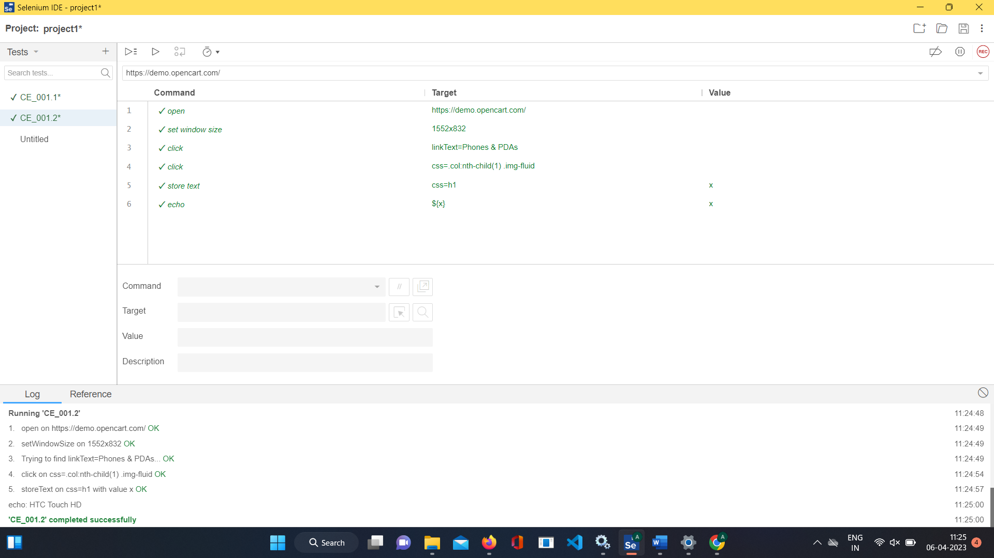

**Task 03:** Selenese Commands

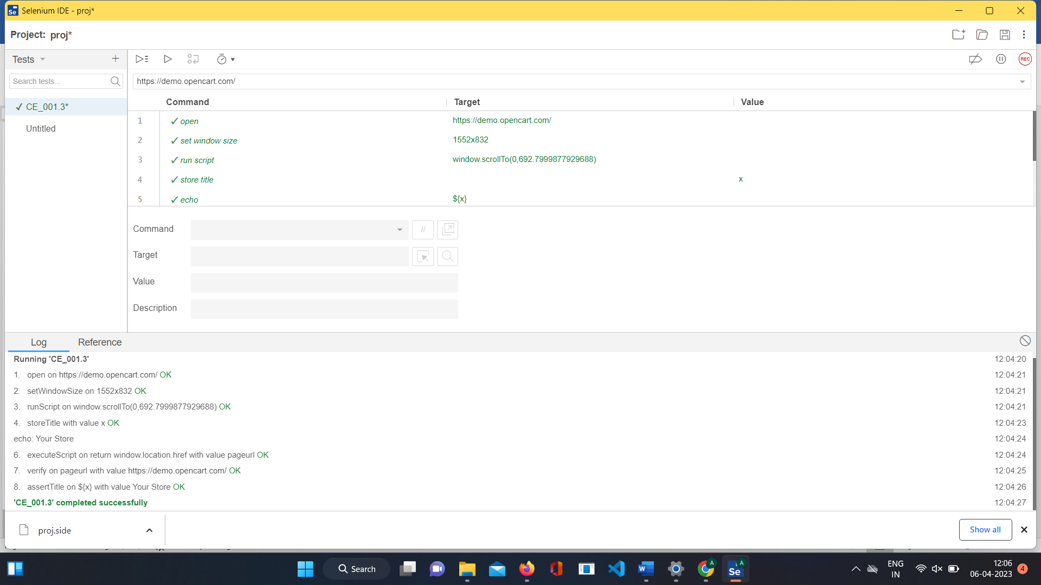

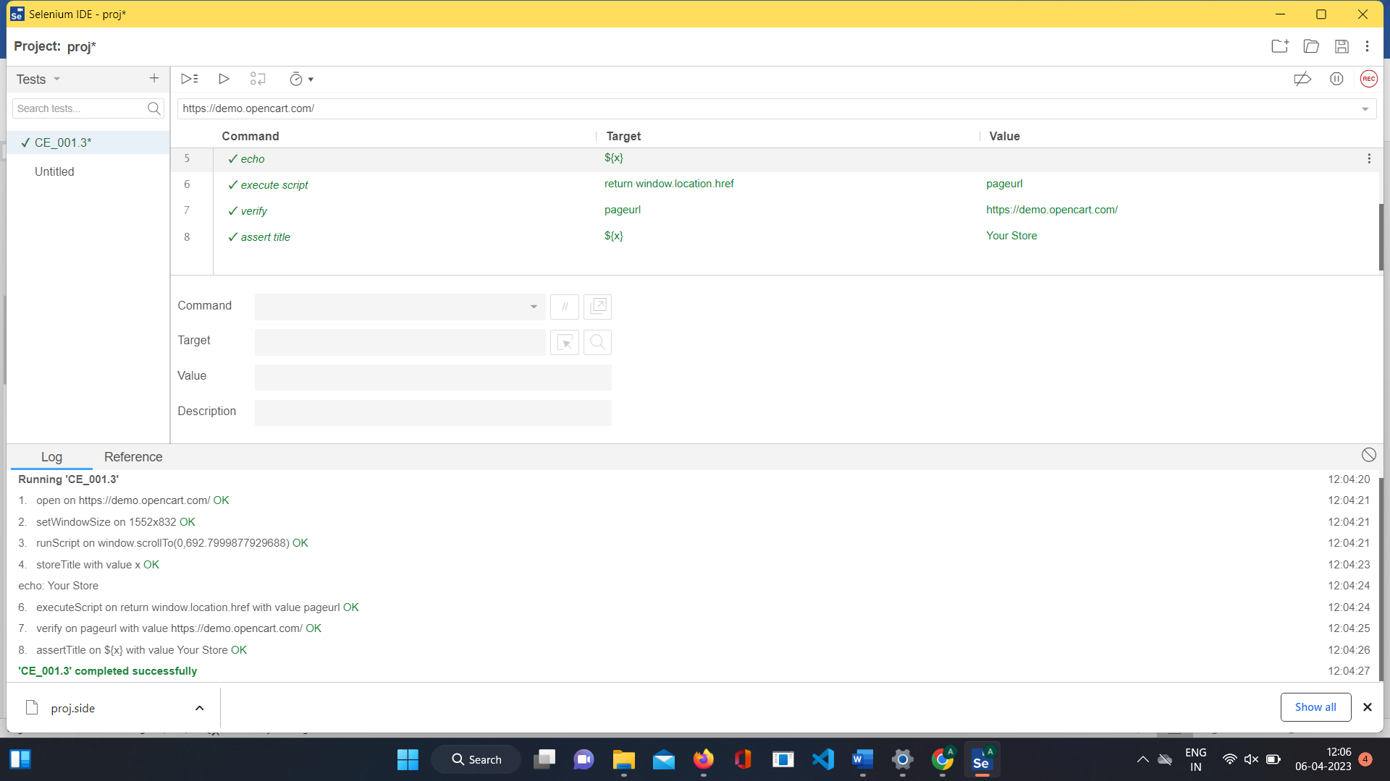

**Task 04:** Selenese Commands

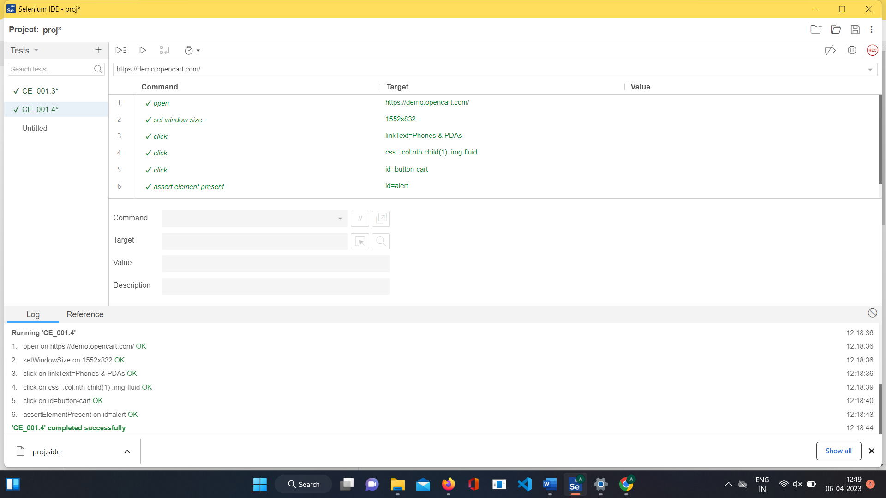

**Task 05:** Selenese Commands

